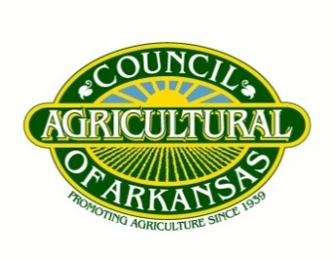
Agricultural Council of Arkansas
Board of Directors Meeting
Jonesboro, AR
August 18, 2022 | 9:30 a.m. – 1:30 p.m.

AGENDA
- Call to Order & Opening Remarks
John King III, President
- Roll Call Introductions & Reports

- Policy Review & Discussion
  - Review and Discussion of Court Decisions on Plant Board
  - Discussion on Upcoming General Session
  - Review and Discussion of Farm Bill
  - Discussion of Other Policy Challenges & Opportunities

- Ag Council Update
Andrew Grobmyer, Executive Vice President

- Other Business
- Adjourn for Lunch

